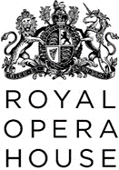
Sustainability Guidance for Costume Designers & Costume Production Managers

The Royal Opera House recognises the climate and ecological crisis and is committed to creating productions that work towards a more sustainable production model.
The Green Production Agreement is included in creative contracts and sets out the basic principles of making productions greener, the aim of this document is to give more detailed guidance.
We encourage the creative team to engage and work with us throughout the design process, so we can achieve the best possible outcome while supporting the aesthetic of the production and integrity of the design.
Links are provided throughout this document to further sustainability guidance within the venue information folder you have access to. If you have any trouble accessing these pages, please contact the Costume Production Manager for help.

The first principles of working greener
- Do more with less
- Use more reused components and recycled materials
We encourage Designers to work with the Costume Production Manager (CPM) and consider using costumes that have had a previous life:
- Please consult with the CPM to explore if existing costumes items and fabric from available stock could be repurposed.
- Review the list of general stock items with consideration to using e.g., belts, ties, t-shirts, underpinnings etc.
- Where in-house reuse isn’t an option, we encourage the purchase of costume items from second-hand or vintage sources.

The creative and costume teams for The Marriage of Figaro started with materials from existing ROH stock that were durable and kinder to the environment. Linens and cottons were used for those performing as the household staff and fine silks for the gentry to create costumes that looked authentic to the 16th century. Natural fibres are durable, easier to dye and can be washed using gentler detergents that are less environmentally damaging.

Most wigs used on our most recent production of Rusalka were from general stock, supporting the principles outlined in the Green Book. The wigs can be stored for future revival or kept as general stock.
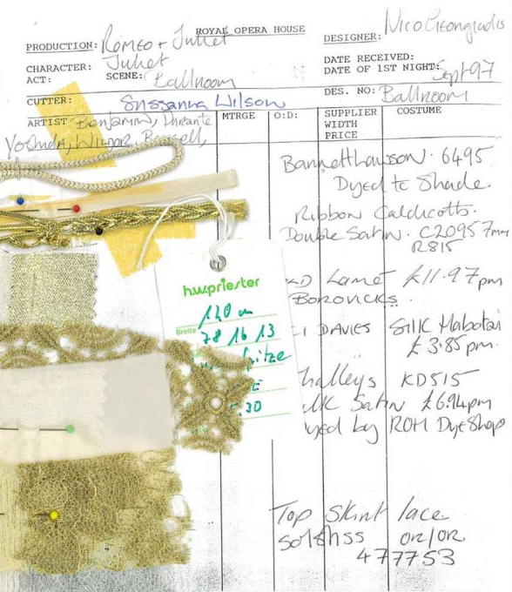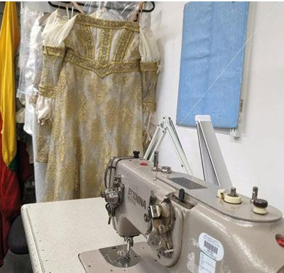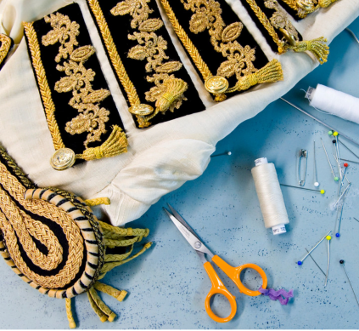
At 50+ years Romeo and Juliet is one of our oldest productions and is regularly revived for the main stage. The image on the left shows a page from the Romeo and Juliet costume bible with original fabric swatches and trim for each costume. The Juliet ballroom dress pictured was worn by both Darcey Bussell and Fumi Kaneko.

Source sustainably
- Make conscious material choices
- Reduce the use of harmful chemicals and processes
We encourage Designers to engage with the CPM as early as possible and as frequently as appropriate, to allow time for sustainable sourcing in the early stages of the production.

- When buying from new, please work with the CPM to consider retailer environmental policies and the fabric that the garment is made from. Trading standard certifications that may indicate good standard include GOTS, GRS, OEKO-TEX and Fairtrade.

- We would actively encourage a move away from fast fashion which has environmental and ethical problems associated with it. More detailed guidance has been provided in the ROH Sustainability Guidance folder to help us make these choices, including further information on the material hierarchy & certifications and textile purchasing.
- Sustainability ratings for high street retailers can also be found here: https://thegoodshoppingguide.com/subject/ethical-fashion-retailers/

- Wherever possible, natural fabrics, organic cottons and recycled or deadstock fabrics should be sourced for making costumes. Textiles should ideally be manufactured or produced as locally as possible (UK based for example).
  - The Costume Directory provides a more in-depth look at textile sustainability here: https://www.sineadkidao.com/the-costume-directory

- Textiles should ideally be washable to avoid chemical or dry cleaning.

- Some materials used in costume, wigs and make-up are particularly damaging. These include glitter, synthetic dyes and products containing parabens and triclosan (antibacterial). Please work with CPMs to identify alternatives where possible. Cosmetic products should ideally be accredited with an EU Ecolabel, Ecocert, COSMOS or similar and come in recyclable packaging.
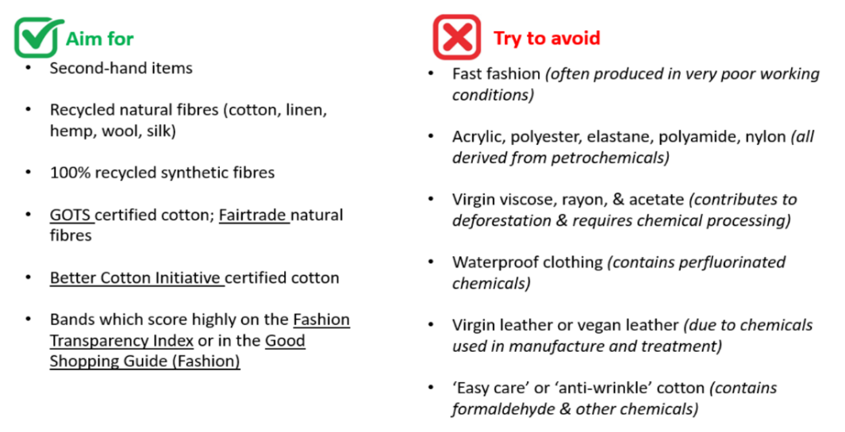
  - A list of recommended suppliers and alternative products is provided in the ROH Sustainability Guidance folder
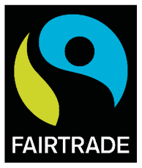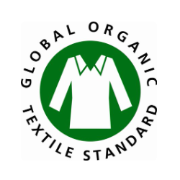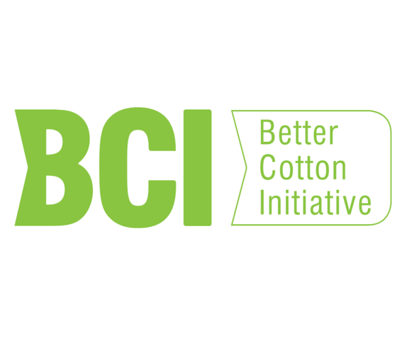
A company’s sustainability commitments are most often reflected by their credentials, including environmental and fairtrade certifications. These certifications may either apply to the company as a whole or to specific products they source. Key labels to look out for are shown above.

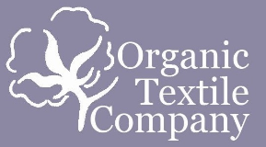
We have created a list of textile suppliers and products with strong credentials to help teams make more sustainable purchases for productions. You can access this list here.

A future life for costumes
- Enable a future of designed elements through the design, construction method and materials chosen
To help us work towards more sustainable productions and report on our actions, we would encourage Designers to work with CPMs to think about choices made and to keep a record of greener decisions, or why a more sustainable option was not appropriate for a particular design.
The future life of a costume is a key driver for sustainability:
- Can we ensure that costumes are in a suitable condition to be returned to general ROH stock at the end of the show’s run?
- Can we ensure that costumes are in a suitable condition to be stored and reused in future revivals?
- Are we able to create universal pieces that could have a second life in other productions?
- Have we considered the construction of the costume to allow for removal of certain elements that are decorative, or provide a special effect e.g. oil stain or blood?
Deliveries, last minutes changes, and waste
- Reduce travel of persons and materials
We aim to combine orders to avoid the need for multiple deliveries from the same supplier, we want to reduce the reliance on last minute ordering, and we would like to use local suppliers as much as possible. The earlier in the process that design designs are made, the more ethical and sustainable the choices that can be made by the CPMs and the Workrooms.
To avoid courier and the carbon costs that every journey generates, please help us avoid last minute or one-off deliveries and returns. Making decisions as early as possible in the production process will give us time to source and return in a more carbon conscious way.
Lastly, please be aware that returns are often destroyed rather than the company incur the laundry, labour and repackaging costs of returning items to sale. This becomes more problematic when multiple items are sampled and returned as we know that multiple items will be destroyed. Returning in-store is preferrable, as return-to-sale is then more likely, but multiple sampling and last-minute choices make this problematic.
Modern slavery
As the manufacture of fabric and costumes has raised well-publicised ethical considerations in countries around the globe, we would like to take the opportunity to highlight the principles in the ROH Modern Slavery and Human Trafficking Statement provided in the Sustainability Guidance Folder.
Here to help
Lastly, we’re here to help. If you need support identifying sustainable suppliers, checking credentials, or have any questions please get in touch at XXXXXX.

