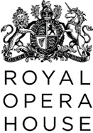
Sustainability Guidance for Production Designers & Production Managers

The Royal Opera House recognises the climate and ecological crisis and is committed to creating productions that work towards a more sustainable production model, working to the guiding principles of the Theatre Green Book
The Green Production Agreement is included in creative contracts and sets out the basic principles of making productions greener, the aim of this document is to give more detailed guidance.
We encourage the creative team to engage and work with us throughout the design process, so we can achieve the best possible outcome while supporting the aesthetic of the production and integrity of the design.
Links are provided throughout this document to further sustainability guidance within the venue information folder you have access to. If you have any trouble accessing these pages, please contact the Production Manager for help.

The first principles of working greener
- Do more with less
- Use more reused components and recycled materials
As part of the ROH’s commitment to making more sustainable productions, sustainability should be considered at the start of the design process prior to the concept design presentation (white card).
We encourage Designers to engage with the Production Manager (PM) as early as possible and as frequently as appropriate, to allow time for sustainable decision making in the early stages of the production.
Production Managers and Makers will offer feedback on the environmental impact of their design choices, and we would ask Designers to consider more sustainable options when presented.
The Green Book encourages creative teams to find reused component or recycled materials as one of their first steps in the design process. We encourage Designers to consult with the PM to:

Maximise sharing across productions

- Review available production assets from live shows such as revolves and modular stretch frames depending on the availability of them within our rep and with our co-production partners.
- Review general stock items for stage such as softs, masking flats, steel deck (for Linbury shows) and stock infill based on the availability of them within our Rep.
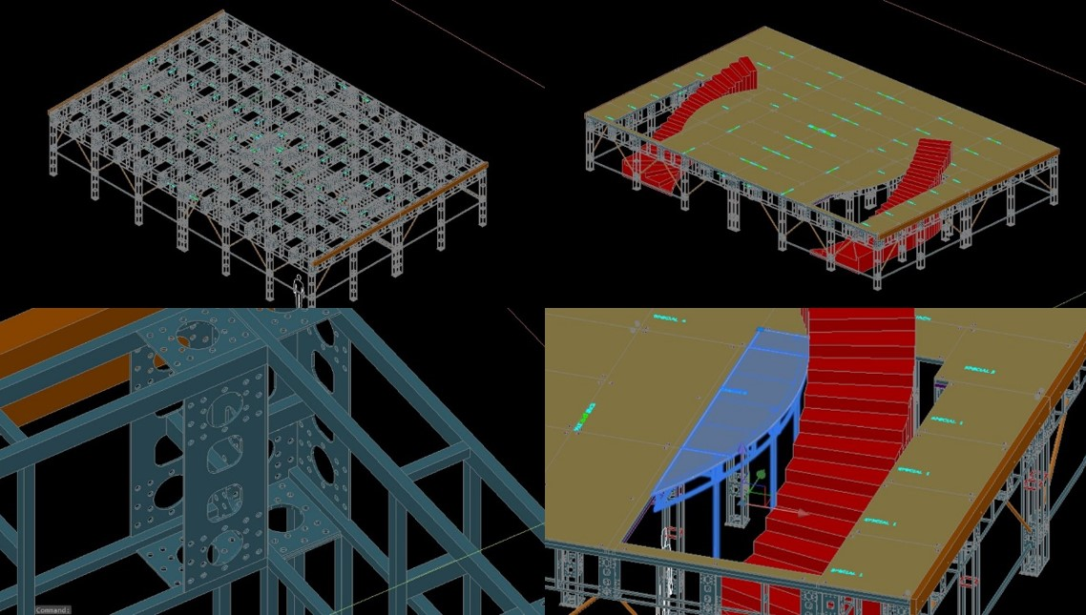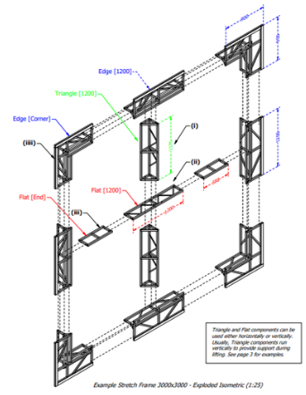
An introductory guide to ROH’s modular stretch frame stock has been provided in the ROH Sustainability Guidance folder here. The Scenic Construction office can offer further guidance and information on available stock pieces, including infills, upon request.

Maximise reuse of resources

- We encourage Designers to consult with the PM to explore if any existing items, textiles or archived scenery can be repurposed or reused.

- Where in-house reuse isn’t an option, we encourage the purchase of scenic items from second-hand sources where possible, preferably locally.

- A list of second-hand platforms such as The Props List, Set Exchange, and Footprint, a sustainable contractor for set & scenery, are provided here.

Source sustainably
- Make conscious material choices
- Reduce the use of harmful chemicals and processes
We encourage Designers to engage with the PM and workshops as early as possible and as frequently as appropriate, to allow time for sustainable sourcing in the early stages of the production.

- When buying from new, production teams should consider retailer environmental policies and purchase low carbon materials. These include FSC timber, board, recycled steel, natural & organic materials and low VOC & water-based paints/adhesives/dyes.

- We would actively encourage a move away from the purchase of virgin and raw materials with a high carbon footprint. These include virgin steel, PVC, tropical hardwood, synthetic textiles, glitter and toxic paints/adhesives/dyes. More detailed guidance has been provided in the ROH Sustainability Guidance folder to help us make these choices:
  - Further information on certifications and the material hierarchy here
  - A list of recommended suppliers and products can be found here
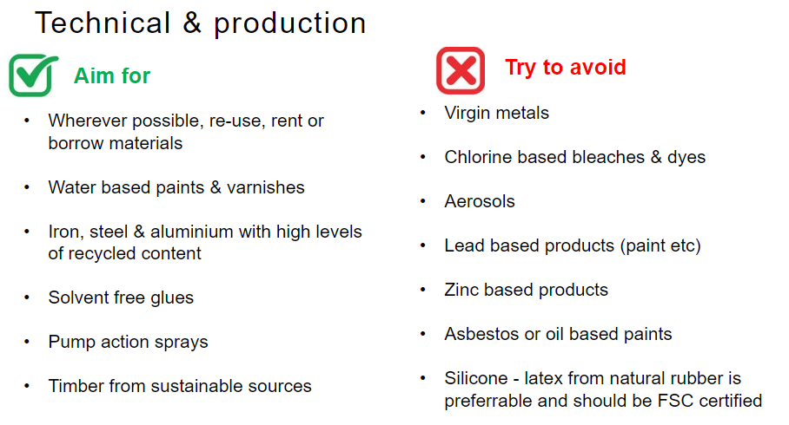
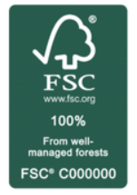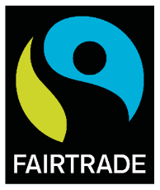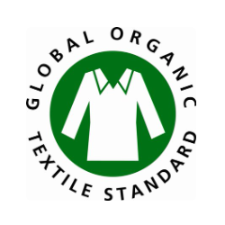
A company’s sustainability commitments are most often reflected by their credentials, including environmental and fairtrade certifications. These certifications may either apply to the company as a whole or to specific products they source. Key labels to look out for are shown above.
A future life for set and scenery
- Enable a future of designed elements through the design, construction method and materials chosen
To help us work towards more sustainable productions and report on our actions, we would encourage Designers to work with PMs to think about choices made and to keep a record of greener decisions, or why a more sustainable option was not appropriate for a particular design.
The future life of set and scenery is a key driver for sustainability:
- Can we ensure set & scenery is in a suitable condition to be returned to general ROH stock or stored for future revival?
- Are we able to create universal pieces that could have a second life in other productions?
- Can we design sets and scenery to allow easier disassembly and reuse of materials at the end of its final run?
Designing and constructing in such a way that allows for the component to be taken apart can help ensure materials are reused or recycled after a production is complete.
This may mean keeping materials in sheet form, using standard sizes, using mechanical connections like bolts, screws, pins and clamps, and keeping clear drawings and instructions to aid disassembly.
You can read more about Making for Disassembly on the Green Book website.
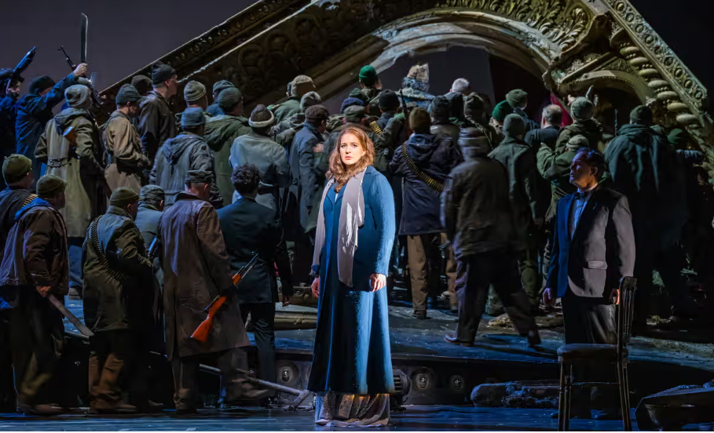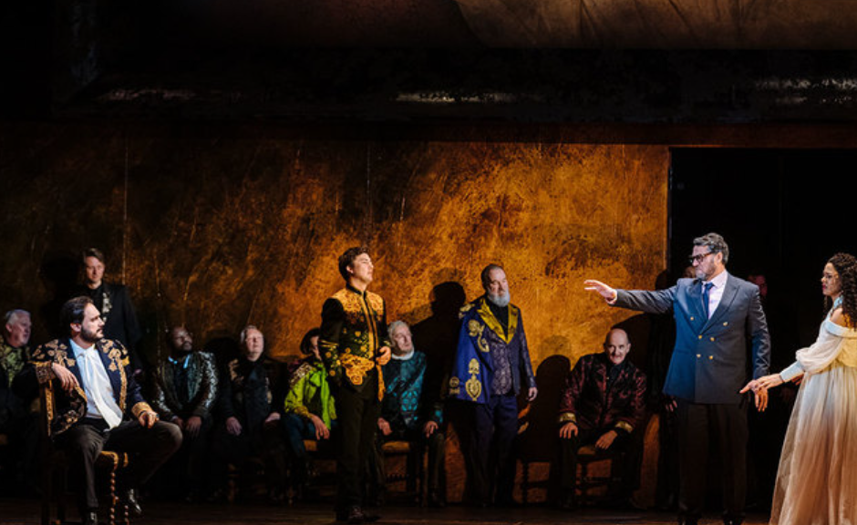
(Left): Tim Albery’s 2010 production of Wagner’s Tannhäuser during its second revival in January 2023; (Right) Oliver Mear’s 2021 production of Rigoletto during its 2023 revival.

Deliveries, last minutes changes, and waste
- Reduce travel of persons and materials
We aim to combine orders to avoid the need for multiple deliveries from the same supplier, we want to reduce the reliance on last minute ordering, and we would like to use local suppliers as much as possible.
We encourage Production Designers to work with PMs to consider standard sizes of materials such as timber sheets and steel sections to minimize waste.
The earlier in the process that design decisions are made, the more ethical and sustainable the choices that can be made by the PMs and the Workshops.
We strongly encourage creative teams to make decisions as early as possible in the production process to give PMs time to source and return purchases in a more carbon conscious way, and there are carbon costs in last-minute decision making and increased use of couriers and discarded materials.
Lastly we encourage PMs to work with the creative and technical teams to reduce the number of pallets needed to transport the production between Purfleet, Covent Garden and Aberdare through efficient packing and set construction.
Modern slavery
We would like to take the opportunity to highlight the principles in the ROH Modern Slavery and Human Trafficking Statement attached as an appendix to this guidance.
Here to help
Lastly, we’re here to help. If you need support identifying sustainable suppliers, checking credentials, or have any questions please get in touch at XXXXX

The Theatre Green Book outlines a path towards sustainability for the industry, mapping a journey towards a way of theatre-making that is low carbon and low waste, values people, and contributes to a more sustainable society https://theatregreenbook.com/

